Nutrition Fact Panel

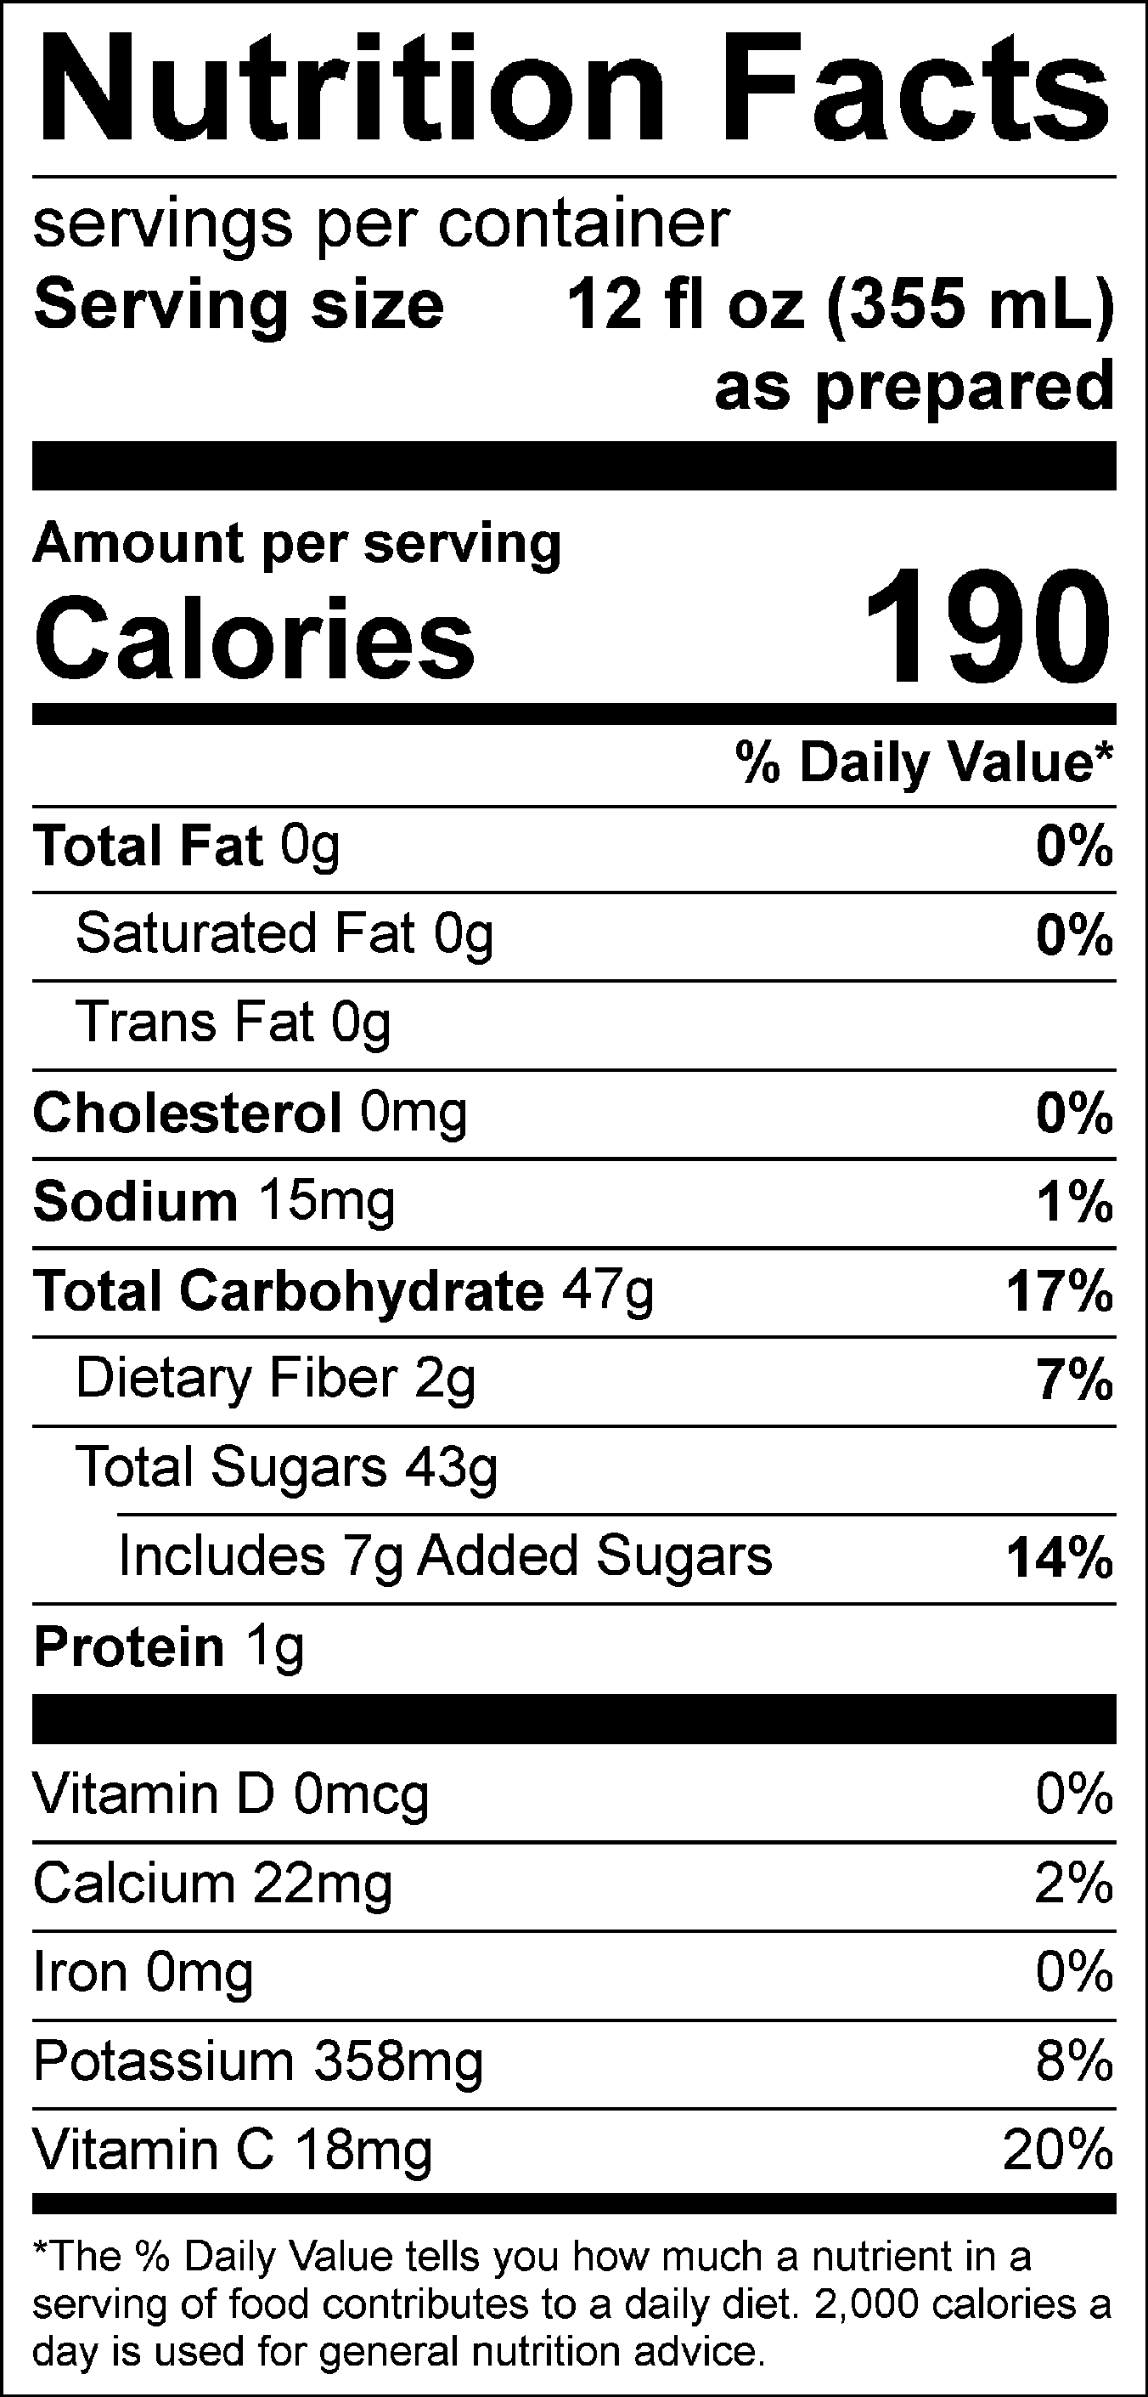
INGREDIENTS: APPLE JUICE FROM CONCENTRATE (WATER, APPLE JUICE CONCENTRATE), MANGO PUREE FROM CONCENTRATE (WATER, MANGO PUREE CONCENTRATE), PINEAPPLE JUICE FROM CONCENTRATE (WATER, PINEAPPLE JUICE CONCENTRATE), BANANA PUREE, WATER, SUGAR, CITRIC ACID, PUMPKIN JUICE CONCENTRATE (COLOR), NATURAL FLAVORS, CAROB GUM, MODIFIED CELLULOSE, ANNATTO (COLOR), PECTIN.
ALLERGEN INFORMATION: MAY CONTAIN TRACES OF MILK, SOY, TREE NUTS, PEANUTS, WHEAT, OR EGGS FROM MANUFACTURING AND BLENDING.

