Contains 26% Juice

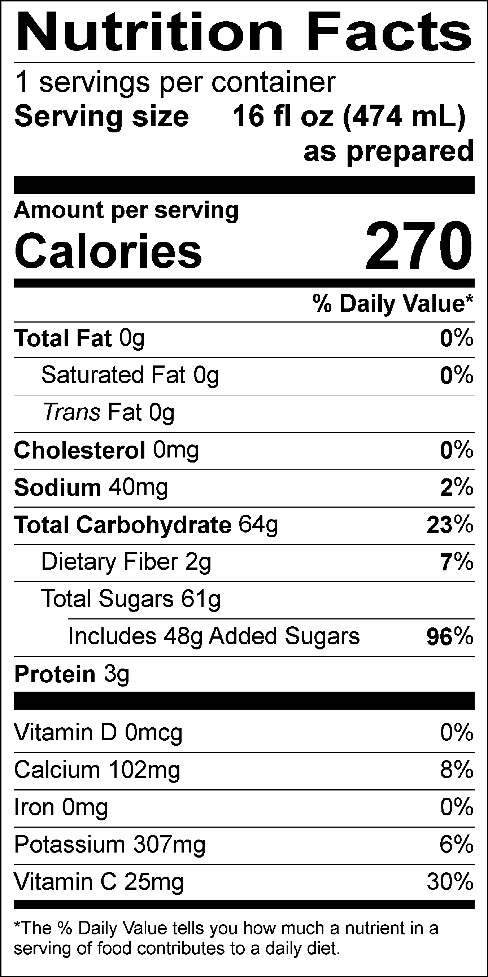

INGREDIENTS: WATER, STRAWBERRY PUREE, SUGAR, BANANA PUREE, SKIM MILK, DEXTROSE, FRUCTOSE, CITRIC ACID, GUAR GUM, NATURAL FLAVORS, BEET JUICE (COLOR).
Allergen Information: Contains Milk. May contain traces of peanuts, tree nuts, soy, wheat, or eggs from manufacturing and blending.
GMO Information: Derived from bioengineering.
Manufactured for f’real foods LLC, Emeryville, CA 94608

