Contains 32% Juice

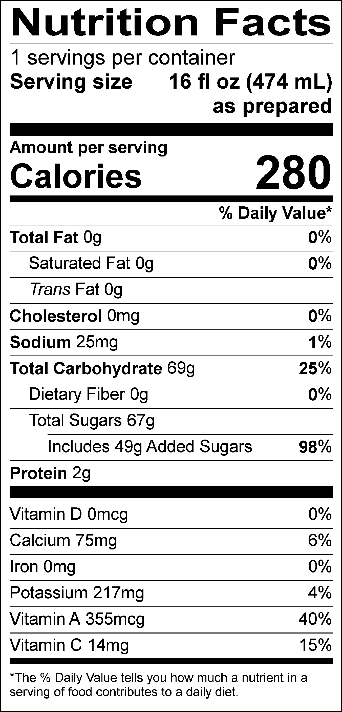
INGREDIENTS: WATER, SKIM MILK, SUGAR, MANGO PUREE CONCENTRATE, PINEAPPLE JUICE CONCENTRATE, FRUCTOSE, DEXTROSE, CITRIC ACID, NATURAL FLAVORS, PUMPKIN JUICE (COLOR), ANNATTO (COLOR), GUAR GUM.
Allergen Information: Contains Milk. May contain traces of peanuts, tree nuts, soy, wheat, or eggs from manufacturing and blending.
GMO Information: Derived from bioengineering.
Manufactured for f’real foods LLC, Emeryville, CA 94608

