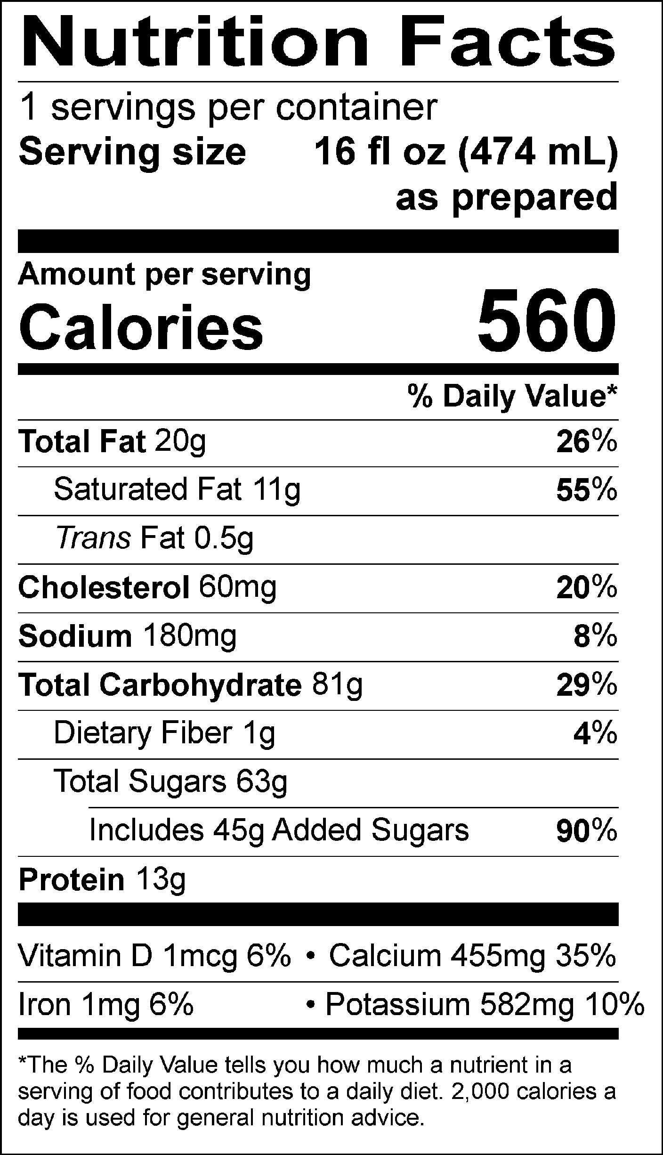
INGREDIENTS: MILK, CREAM, BUTTERMILK, SUGAR, CORN SYRUP, OREO® COOKIE PIECES (UNBLEACHED ENRICHED FLOUR [WHEAT FLOUR, NIACIN, REDUCED IRON, THIAMINE MONONITRATE {VITAMIN B1}, RIBOFLAVIN {VITAMIN B2}, FOLIC ACID], SUGAR, PALM AND/OR CANOLA OIL, COCOA PROCESSED WITH ALKALI, INVERT SUGAR, LEAVENING [BAKING SODA AND/OR CALCIUM PHOSPHATE], SOY LECITHIN, SALT, CHOCOLATE, NATURAL FLAVOR), SKIM MILK, WATER, NATURAL AND ARTIFICIAL FLAVOR, GUAR GUM, CAROB GUM.
Allergen Information: Contains Milk, Wheat, and Soy. May contain traces of peanuts, tree nuts, or eggs from manufacturing and blending.
GMO INFORMATION: Derived from bioengineering.
Manufactured for f’real foods LLC, Emeryville, CA 94608

