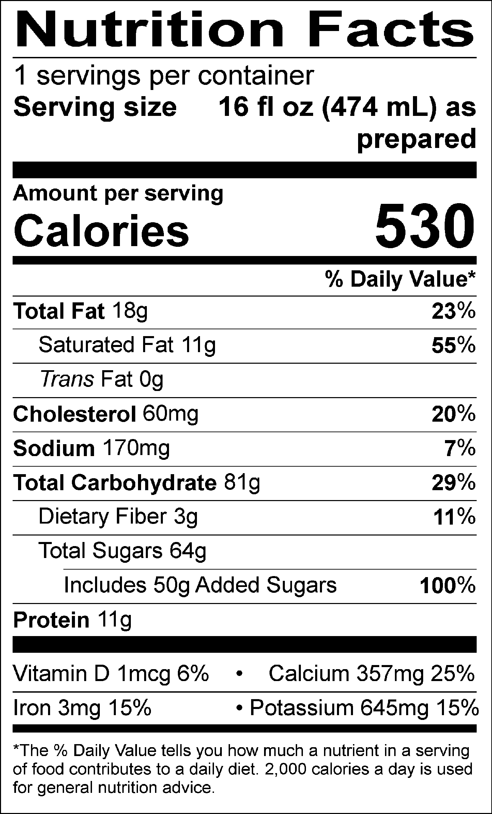

INGREDIENTS: MILK, CREAM, BUTTERMILK, SUGAR, CORN SYRUP, SKIM MILK, WATER, COCOA, COCOA PROCESSED WITH ALKALI, GUAR GUM, CAROB GUM.

Allergen Information: Contains Milk. May contain traces of peanuts, tree nuts, soy, wheat, or eggs from manufacturing and blending.

GMO Information: Derived from bioengineering.

Manufactured for f’real foods LLC, Emeryville, CA 94608

