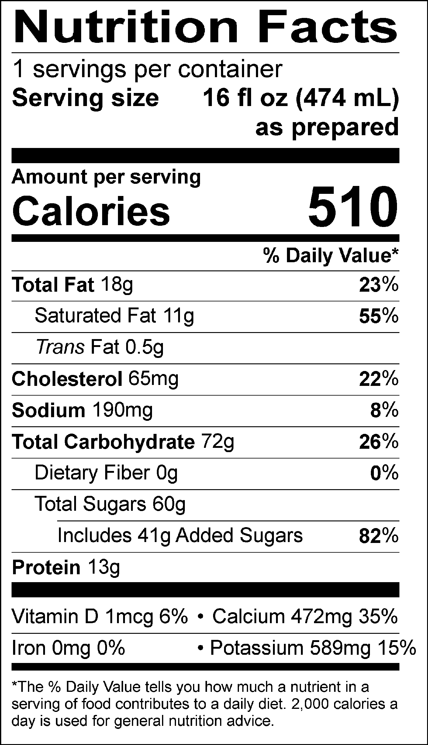

INGREDIENTS: MILK, CREAM, BUTTERMILK, SUGAR, CORN SYRUP, SKIM MILK, WATER, NATURAL AND ARTIFICIAL VANILLA FLAVORS, GUAR GUM, CAROB GUM.
Allergen Information: Contains Milk. May contain traces of peanuts, tree nuts, soy, wheat or eggs from manufacturing and blending.
GMO Information: Derived from bioengineering.
Manufactured for f’real foods LLC, Emeryville, CA 94608

