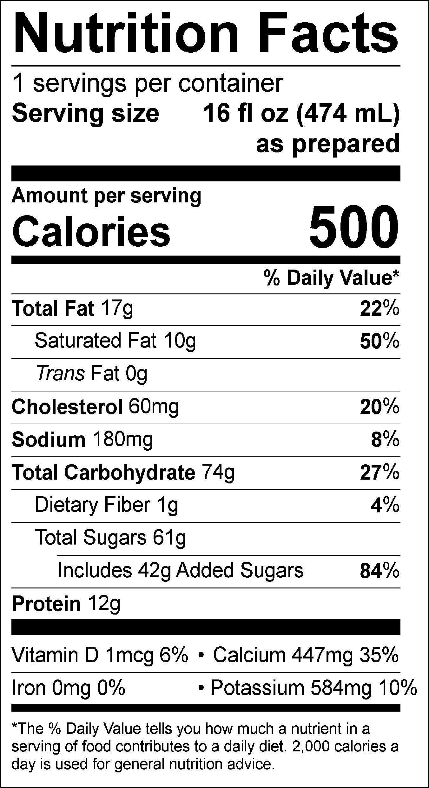

INGREDIENTS: MILK, CREAM, BUTTERMILK, SUGAR, CORN SYRUP, SKIM MILK, STRAWBERRY PUREE, WATER, CITRIC ACID, BEET JUICE (COLOR), GUAR GUM, CAROB GUM, NATURAL FLAVOR.

Allergen Information: Contains Milk. May contain traces of peanuts, tree nuts, soy, wheat, or eggs from manufacturing and blending.
Manufactured for f’real foods LLC, Emeryville, CA 94608

