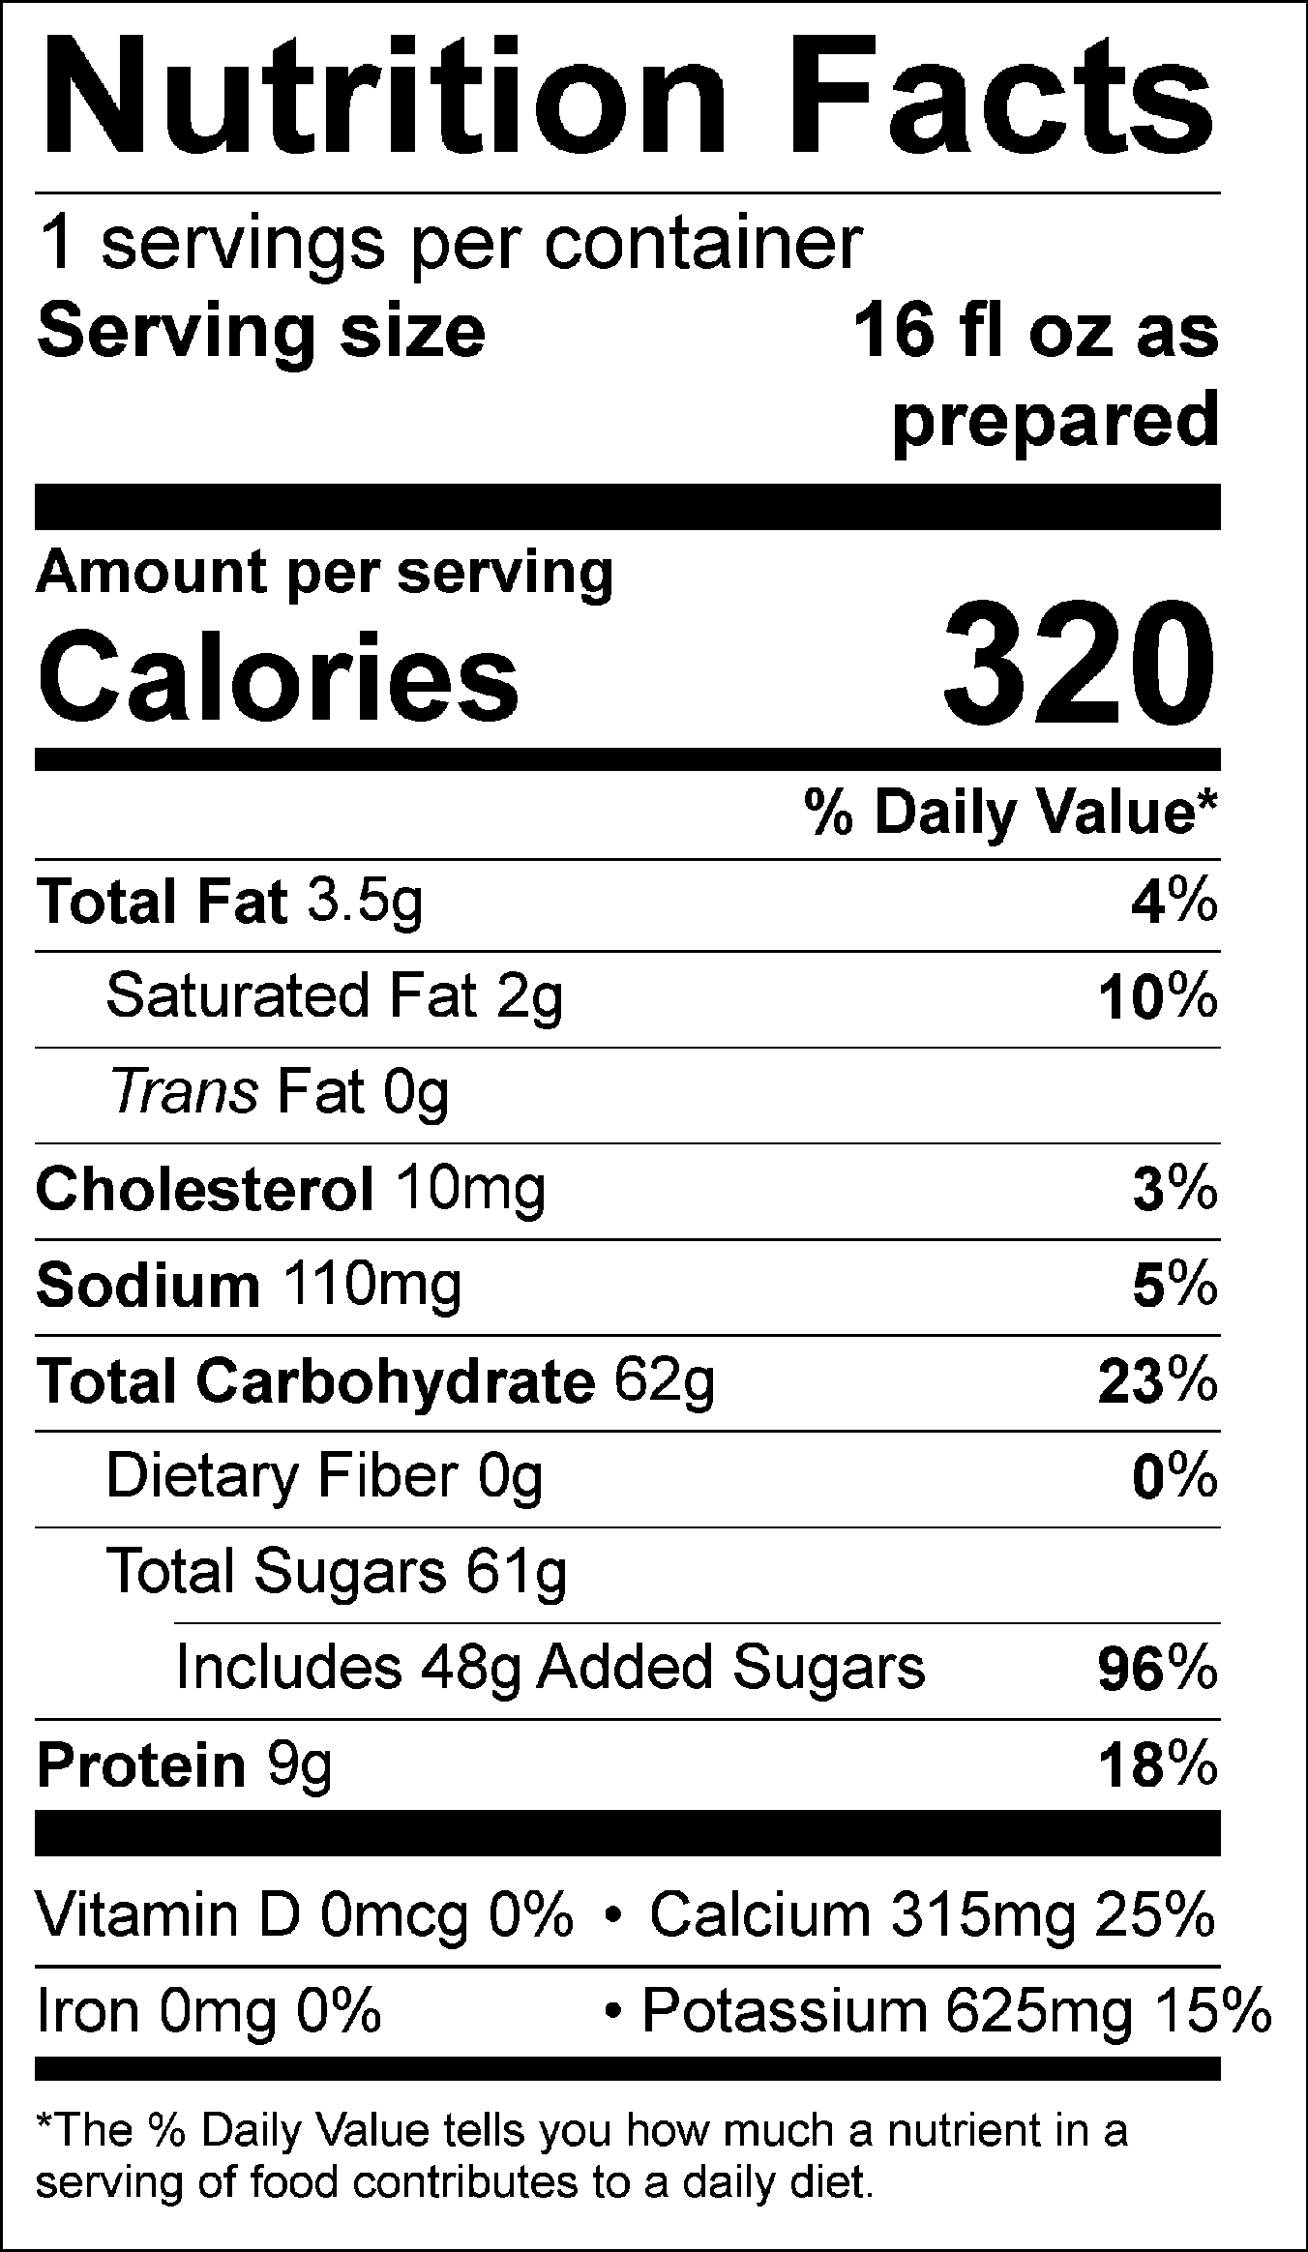

INGREDIENTS: WATER, MILK, SUGAR, BREWED COFFEE (WATER, 100% ARABICA COFFEE), SKIM MILK, GUAR GUM.

Allergen Information: Contains Milk. May contain traces of peanuts, tree nuts, soy, wheat, or eggs from manufacturing and blending.
Manufactured for f’real foods LLC, Emeryville, CA 94608

