Product Name: Snickers Milkshake

Nutrition Fact Panel
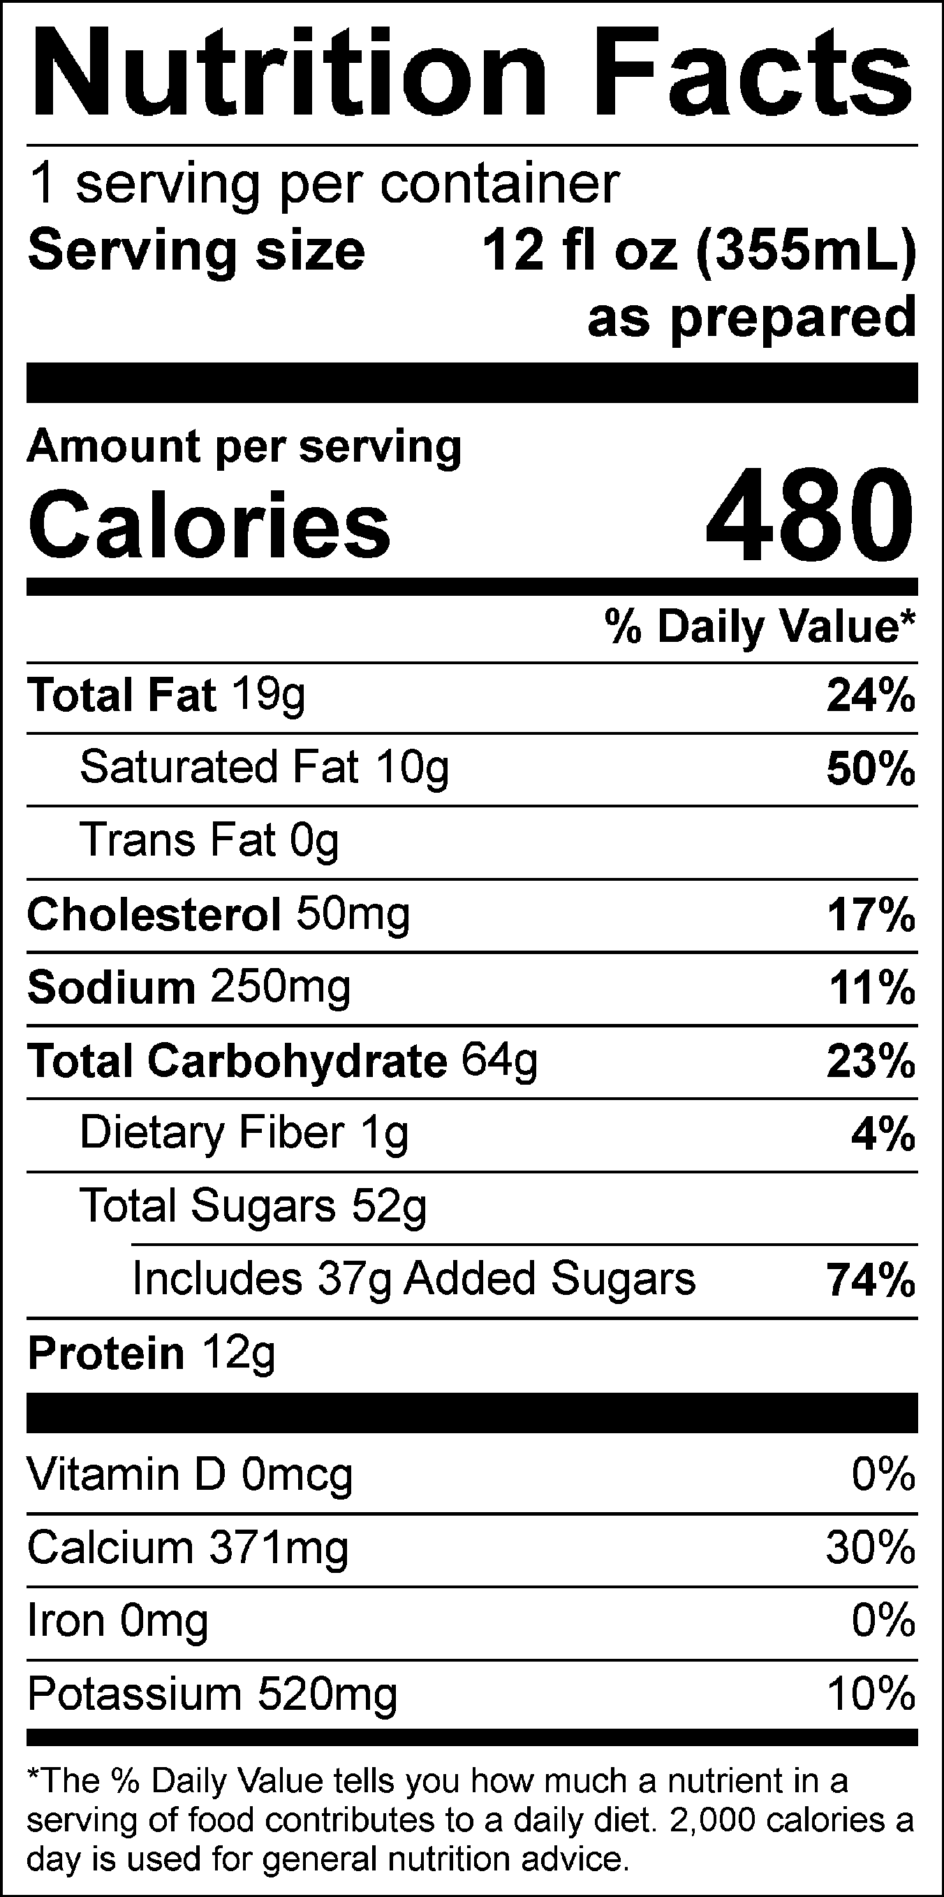

INGREDIENTS: MILK, SKIM MILK, CREAM, SUGAR, CORN SYRUP, SNICKERS® CANDY PIECES (MILK CHOCOLATE [SUGAR, COCOA BUTTER, CHOCOLATE, SKIM MILK, LACTOSE, MILKFAT, SOY LECITHIN], PEANUTS, CORN SYRUP, SUGAR, PALM OIL, SKIM MILK, LACTOSE, SALT, EGG WHITES, ARTIFICIAL FLAVOR), ROASTED PEANUTS, NATURAL AND ARTIFICIAL FLAVORS, GUAR GUM, PEANUT OIL, CAROB GUM, SEA SALT.

Contains Milk, Peanuts, Soy, Eggs. May contain traces of tree nuts or wheat from manufacturing and blending.

SNICKERS is a trademark of Mars or Affiliates. Used under license.

